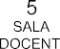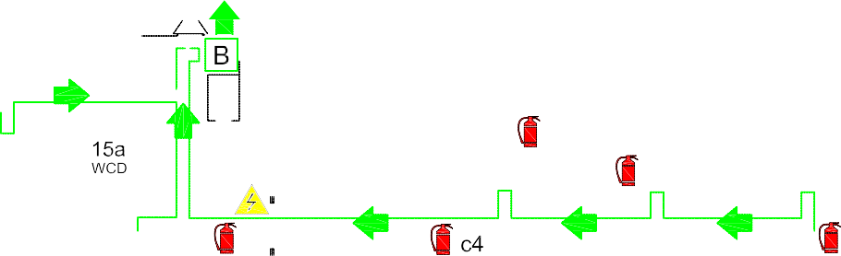

(27) (27) (28) (27)

Aula9
2E

Aula 10
1CL (28)

Aula 11 1DL 2DL 1AC 2AC
2CL (23) (25) (25) (29)

1DL (23)

1BC

(24)
2BC

(24)

1AL
(30) 2AL 1EC 2EC (26) 2GL(25)
(27)
(25)

(28)

(30)
2CL
2EC
1EC
1GL

